**MONIKA SHARMA** 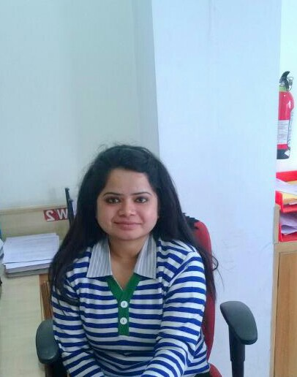

**Email- monika.sharma090@gmail.com Mobile -8004170916**

***Present Address***

*Flat No. 5*

*Subhash Apartment*

*Near Kandawa Gate DLW*

*Varanasi UP*

*PIN-221004*

________________________________________________________________________________________

|  |
| --- |
|  |
| **--: Career Objective :--** | |

To work for organization’s development and growth by timely execution of each and every assignment and making continuous good contribution to the bottom line of the organization

|  |
| --- |
| **--: Overview :--** |

* A Graduate in Business Administration with specialization in Finance and a Post Graduate Diploma holder in Banking Services.
* Worked In an organization of high reputation, seeking assignment especially in Banking Operations

|  |
| --- |
| **--: Expertise :--** |

* **Analysis/Planning**: Framing strategies for individuals and business owners towards the accomplishment of their financial goals **&** providing adequate service to clients by accessing their needs thus generating revenue for the organization.
* **Total sales co-ordination:** Generating profitability through continuous customer acquisition, cross selling as well as planning activities to achieve the sales targets
* **Internal operations:** timely execution of internal operations task within TAT. System productivity (Finnacle software) at present is 189%
* **General Management:** Assisting the supervisor in managing day to day activities of the organization.

|  |
| --- |
| **----------:Work Experience:---------** |

**Axis Bank Ltd(1st June 2013 to 2nd September) 15 months**

Worked as **Assistant Manager Operations** at Axis Bank Limited, at Varanasi Lanka Branch from 1st June 2013 till 2nd September

**Functional Areas**

* Banking operations, Management of branch inventory, vendor management, office accounts monitoring, inward and outward clearing, solving customer complaints and **Backup of Branch Operations Head**
* Assisting the Branch head in managing day to day activities of branch.
* Sales and business development by acquiring new customer.
* Customer requests processing with coordination of **Central Liability Hub**
* Coordination with **Scanning Hub** for account opening proceeds.
* Deliverables custodian ( All Pins )

|  |
| --- |
| **----: Educational Details :---** |

|  |  |  |
| --- | --- | --- |
| Qualification | Details of Qualification | Course Duration |
| **PGDBS** | Manipal University Bangalore Campus ( 7.2 CGPA ) | * From May 2012 toFebruary 2013 |
| **BBA** | School Of Management Sciences Varanasi (VBS Purvanchal University) | * From July 2008 to August 2011 |
| **Intermediate** | Kendriya Vidyalaya DLW Varanasi **PCM**  (CBSE) | * May 2007 |
| **Matriculation** | Little Flower House Varanasi (CBSE ) | * May 2005 |

|  |
| --- |
| **Summer Internship training:**  From 1st March 2013 to 31st May 2013 (**3Months**) |

* Organization:- AXIS BANK LTD.
* Project Title:-“ Corporate & Retail Banking”
* Duration:- Three months (From 1st March 2013 to 31st May 2013)
* Learnings:- The internship program was designed so as to watch and learn day to day banking operational as well as sales activities at large.

|  |
| --- |
| **----: Industrial Visits :----** |

* Visited Axis Bank Ltd. YehLahanka Branch Bangalore in the year 2012 and studied about various day to day Banking Operational Activities.
* Visited Parle Industries Ramnagar Varanasi in the year 2011 and studied about various stages of production & storage.

|  |
| --- |
| **----: Strengths :----** |

* Analytical Skill, Confidence, Determination, Honesty and trustworthiness,
* Group co-ordination behavior, Hardworking & Multi-Tasking

|  |
| --- |
| **Technical Knowledge:** |

|  |
| --- |
| **----: Achievements :----** |

* **NISM Series 5 A qualified.**
* Abilities in **handling** multiple priorities, with a bias for action and a genuine interest in professional development
* An effective communicator with strong interpersonal, presentation and good reasoning skills.
* Actively participated in various cultural social events and seminars conducted by the college
* Participated in youth parliament and other Social activities conducted by Kendriya Vidyalaya Sangathan

|  |
| --- |
| * **----: Apart from Banking operations :--** |

* One among 5% highest achievers in circle of Mutual fund sales in second quarter of FY 2013-14.
* Got recognized for being one among highest contributor in Life insurance business in circle (November 2013), qualified for felicitation in Circle Office.
* Recognized by “EVP & Head-Channels” for achieving 80%+ growth in saving bank balance by acquiring new high value saving accounts).
* Qualified Axis Direct Shubharambh League, topper in Lucknow Circle (Highest no. of OTR acquisition in 1st month of FY 2014-2015)

|  |
| --- |
| * **----: :Personal Details: :----** |

* Languages known -: English and Hindi
* Date of Birth/marital status - 26 January 1990/Single
* Hobbies & Interests -: Reading Books, Cooking
* Permanent address -: Same as Present Address
* Contact/ Email -: Mob-+91-8004170916, **monika.sharma090@gmail.com**